**AGE GROUP WISE MURDER VICTIMS:**

SELECT sum(Victims_Upto_10_Yrs) as Victims_upto_10_Yrs,

sum(Victims_Upto_10_15_Yrs) as Victims_10_15_Yrs, sum(Victims_Upto_15_18_Yrs) as Victims_15_18_Yrs,

sum(Victims_Upto_18_30_Yrs) as Victims_18_30_Yrs, sum(Victims_Upto_30_50_Yrs) as Victims_30_50_Yrs,

sum(Victims_Above_50_Yrs) as Victims_50_Yrs from "32_Murder_victim_age_sex"

WHERE Sub_Group_Name != '3. Total';

**Total Victims below 10 years in India – 6627**

**Total Victims between 10 to 15 years in India – 4177**

**Total Victims between 15 to 18 years in India – 7693**

**Total Victims between 18 to 30 years in India – 158786**

**Total Victims between 30 to 50 years in India – 138075**

**Total Victims above 50 years in India – 32496**

**Among all group by ages, between 18 to 30 years most of the both females and males murdered in India.**

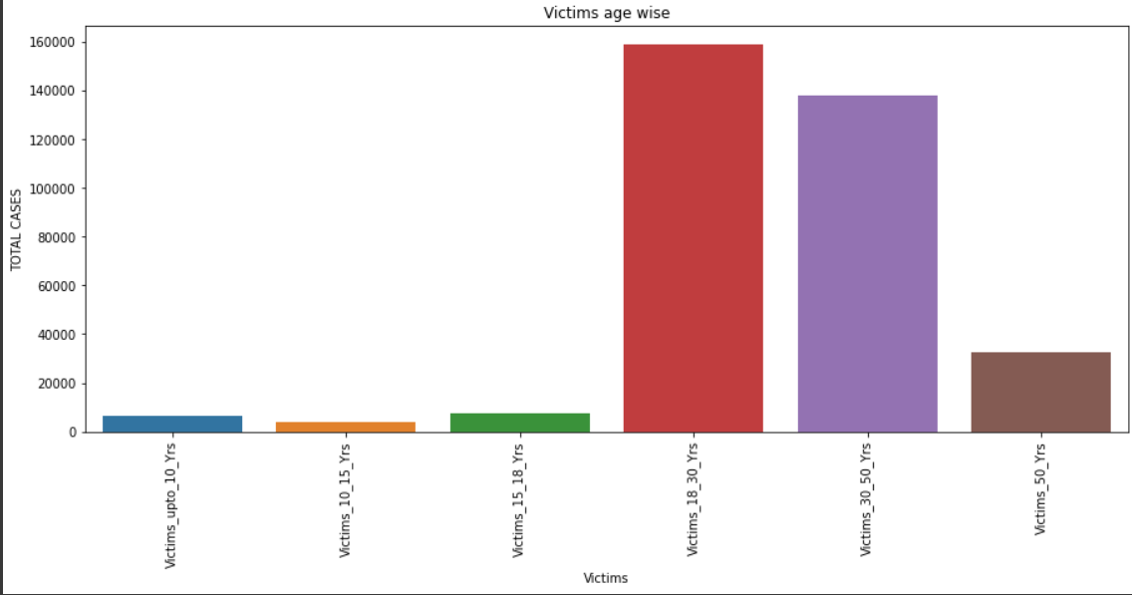

SELECT Sub_Group_Name, sum(Victims_Upto_10_Yrs) as Victims_upto_10_Yrs,

sum(Victims_Upto_10_15_Yrs) as Victims_10_15_Yrs, sum(Victims_Upto_15_18_Yrs) as Victims_15_18_Yrs,

sum(Victims_Upto_18_30_Yrs) as Victims_18_30_Yrs, sum(Victims_Upto_30_50_Yrs) as Victims_30_50_Yrs,

sum(Victims_Above_50_Yrs) as Victims_50_Yrs from "32_Murder_victim_age_sex"

WHERE Sub_Group_Name != '3. Total'

GROUP BY Sub_Group_Name;

**Among all group by ages, between 18 to 30 years of age 119175 males murdered in India.**

**Among all group by ages, between 18 to 30 years of age 39611 females murdered in India.**

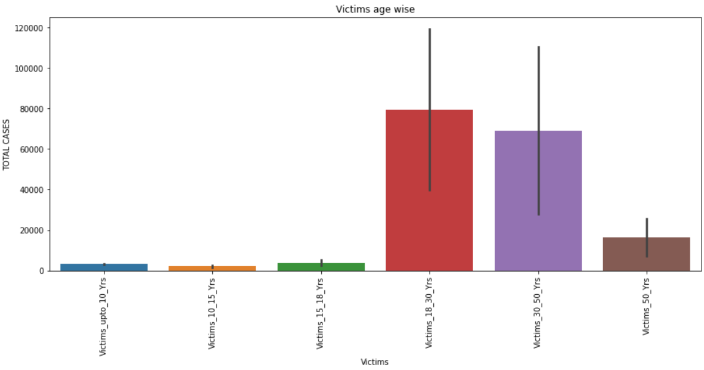

SELECT Area_Name, sum(Victims_Upto_10_Yrs) as Victims_upto_10_Yrs

from "32_Murder_victim_age_sex"

WHERE Sub_Group_Name != '3. Total'

GROUP BY Area_Name

ORDER BY Victims_upto_10_Yrs DESC;

**Maharashtra has highest murder victims that are below 10 years.**

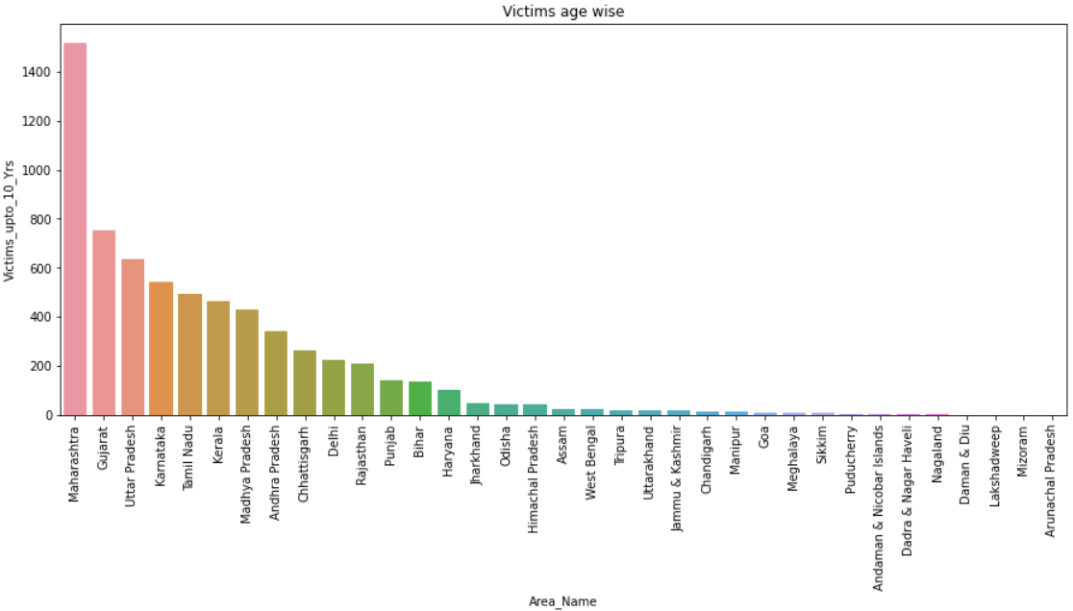

SELECT Area_Name, sum(Victims_Upto_10_15_Yrs) as Victims_10_15_Yrs

from "32_Murder_victim_age_sex"

WHERE Sub_Group_Name != '3. Total'

GROUP BY Area_Name

ORDER BY Victims_10_15_Yrs DESC;

**Uttar Pradesh has highest murder victims that are between 10 to 15 years.**

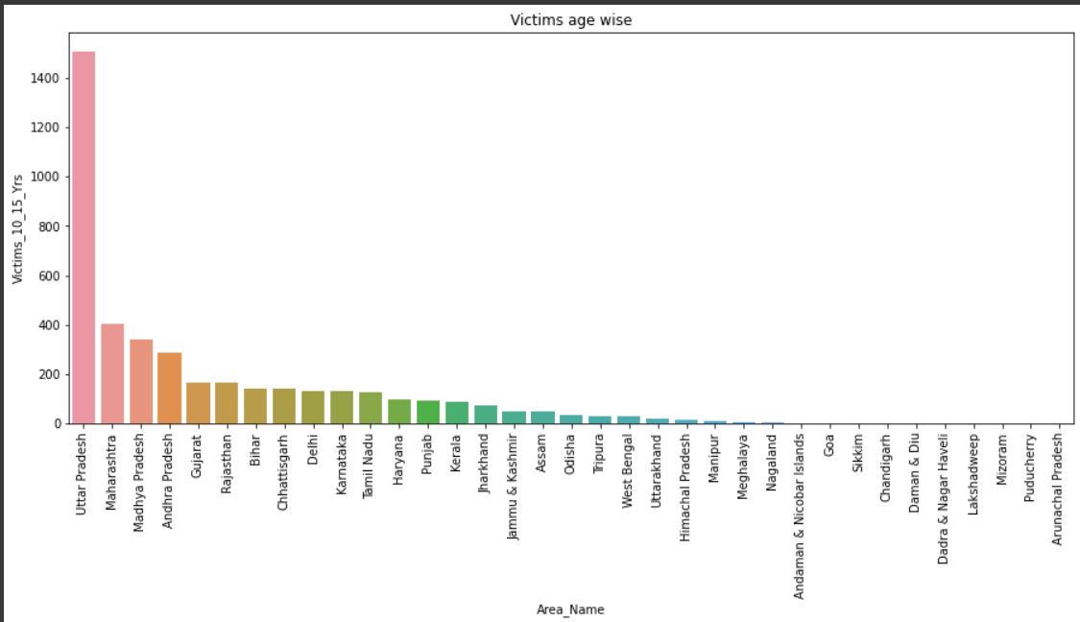

SELECT Area_Name, sum(Victims_Upto_15_18_Yrs) as Victims_15_18_Yrs

from "32_Murder_victim_age_sex"

WHERE Sub_Group_Name != '3. Total'

GROUP BY Area_Name

ORDER BY Victims_15_18_Yrs DESC;

**Uttar Pradesh has highest murder victims that are between 15 to 18 years.**

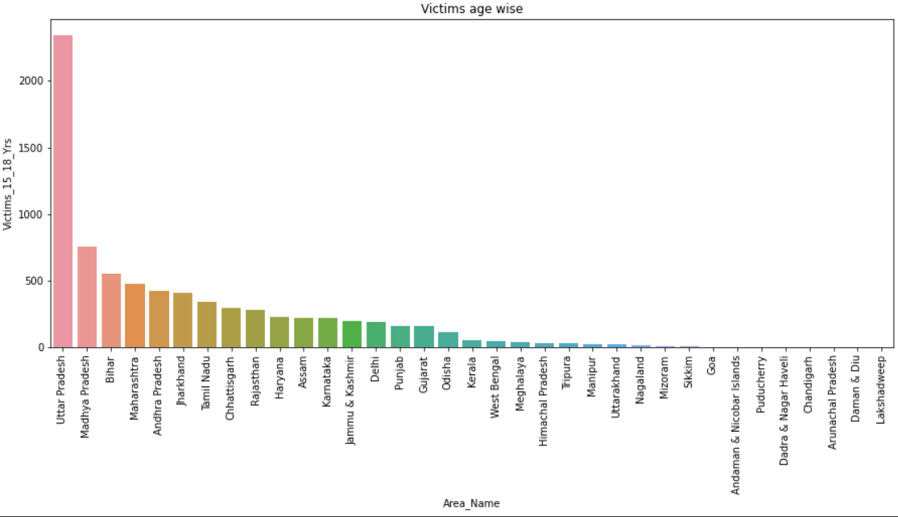

SELECT Area_Name, sum(Victims_Upto_18_30_Yrs) as Victims_18_30_Yrs

from "32_Murder_victim_age_sex"

WHERE Sub_Group_Name != '3. Total'

GROUP BY Area_Name

ORDER BY Victims_18_30_Yrs DESC;

**Uttar Pradesh has highest murder victims that are between 18 to 30 years.**

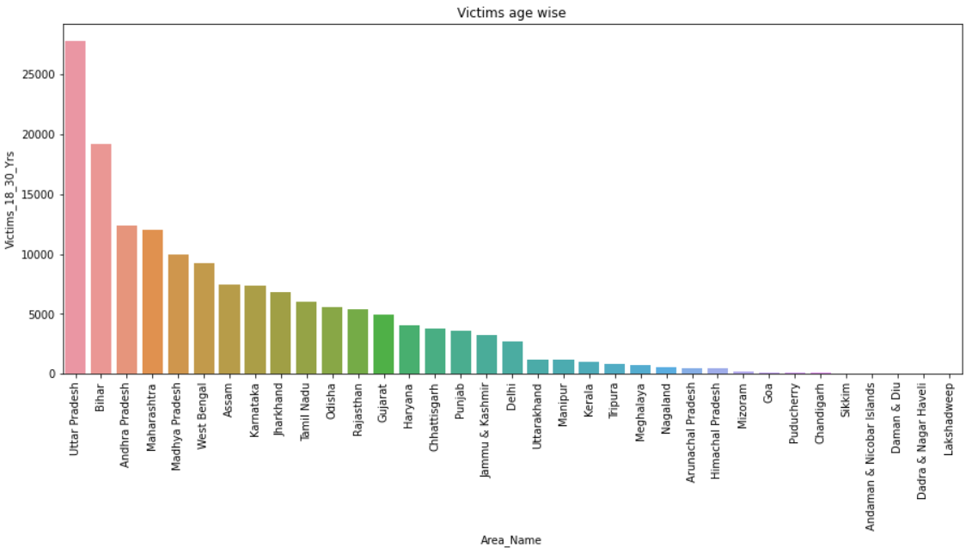

SELECT Area_Name, sum(Victims_Upto_30_50_Yrs) as Victims_30_50_Yrs

from "32_Murder_victim_age_sex"

WHERE Sub_Group_Name != '3. Total'

GROUP BY Area_Name

ORDER BY Victims_30_50_Yrs DESC;

**Uttar Pradesh has highest murder victims that are between 30 to 50 years.**

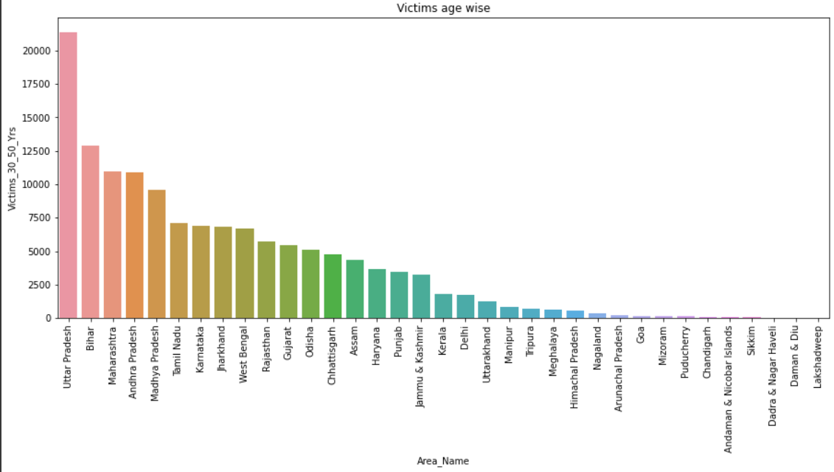

SELECT Area_Name, sum(Victims_Above_50_Yrs) as Victims_50_Yrs

from "32_Murder_victim_age_sex"

WHERE Sub_Group_Name != '3. Total'

GROUP BY Area_Name

ORDER BY Victims_50_Yrs DESC;

**Uttar Pradesh has highest murder victims that are above 50 years.**

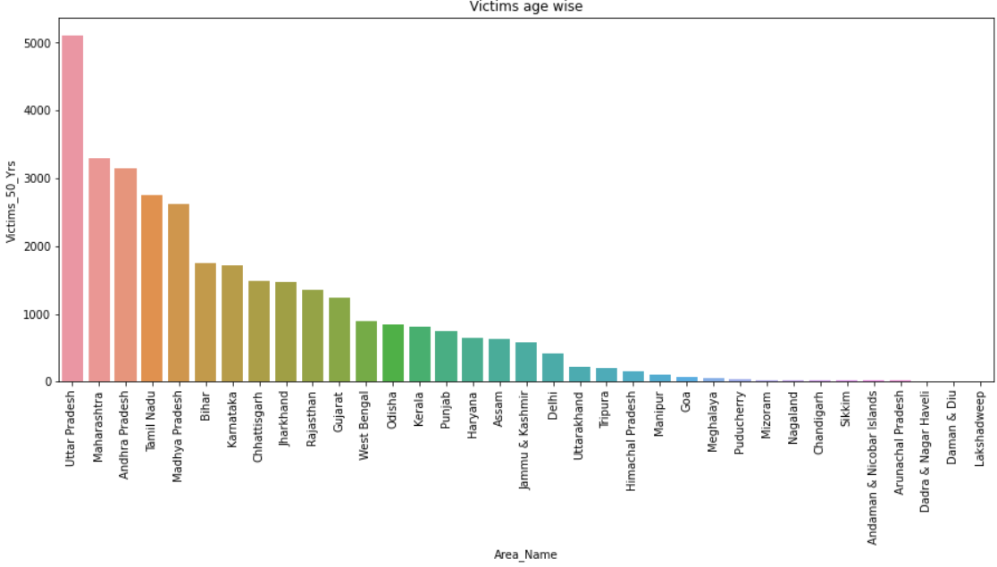

Conclusion: Among all states, Uttar Pradesh has highest murder victims by age group wise.